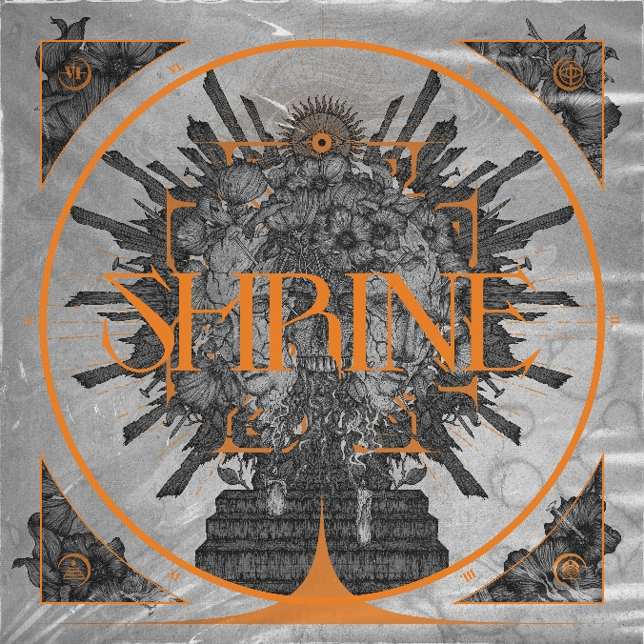

BLEED FROM WITHIN

‘Shrine’

OUT: June 3rd 2022
Line up: | BLEED FROM WITHIN online:
Scott Kennedy | Vocals  Craig Gowans | Guitar  Steven Jones | Guitar  David Provan | Bass  Ali Richardson | Drums | facebook.com/bleedfromwithinband  instagram.com/bleedfromwithin  twitter.com/BleedFromWithin  bleedfromwithin.com
There is no mistaking the sound of a great band with the wind in their sails. BLEED FROM WITHIN have been a potent and reliable presence in the UK metal scene for 17 years now, but recent times have seen the Scottish quintet growing in confidence and stature. With their newest album Shrine, they are about to shatter all previous expectations.
Formed in Glasgow in 2005, BLEED FROM WITHIN emerged from the metalcore explosion and swiftly established themselves as one of the UK’s most distinctive bands. With a sound that drew from all manner of extreme subgenres and an unwavering knack for penning anthemic, memorable anthems, the Scots already sounded like the finished article on their debut album Humanity in 2009, but every subsequent album saw them evolve and gain strength. Both Empire (2010) and big label debut Uprising (2013) consolidated their reputation, while extensive touring and an increasingly sophisticated live show proclaimed a noble devotion to taking their music directly to the masses.
Despite numerous lows to balance out the highs, BLEED FROM WITHIN have defied the odds to become a permanent and much admired fixture in modern metal. In 2018, the widely acclaimed Era – the first to feature the band’s current line-up of vocalist Scott Kennedy, drummer Ali Richardson, guitarists Craig ‘Goonzi’ Gowans and Steven Jones, and bassist Davie Provan - added yet more fuel to their fire and they subsequently embarked on their most comprehensive touring schedule to date. Unfortunately, as work began on the band’s fifth album, the whole world ground to a juddering halt. But despite being released into a strange new reality, 2020’s Fracture proved to be the biggest triumph of the BLEED FROM WITHIN story to date.
“Releasing Fracture during lockdown was a very conscious decision,” explains Ali Richardson. “We had a lot of our peers and even the label suggesting we could push it back if we wanted to, but we were already building momentum at the time that we released it, and we were very aware of that. Off the back of that release we did a full production live stream, and we supported Lamb Of God digitally. I think it did wonders for us, if just for our own mental well-being. We had an album to work and promote and do things with, and obviously we were writing in the background as well, for Shrine.”
“Fracture was ten songs we wrote while we were touring,” adds Steven Jones. “So for that album to do as well as it did, it makes you think, ‘We’ve really got a shot at this!’ People liked the album so much, and it came together because we made it come together. This time around, for Shrine, we’ve had the time we need to put the best possible album that we can together.”
Due for release on June 3 through new label home Nuclear Blast Records, Shrine represents the culmination of all the hard work that BLEED FROM WITHIN have put in over the years. It is also by far the most complete and convincing record the band have ever made. Building on the multi-faceted savagery of Fracture and adding multiple new elements, these new songs are the result of a shared chemistry that has only intensified over time.
“When Steven joined the band (in 2017), we got out of a rut we were in,” admits Ali. “The writing process with the five of us now is brilliant. Steven’s very involved with the vocal engineering and recording, he works closely with Kennedy and they experiment a lot with the melodies that you’re hearing. I like to think of Era and Fracture and Shrine as almost a trilogy, covering the evolution of our sound. We’re already talking about the next album and where we’re going to go, so we’re going to reset a little bit after this.”
Although immediately recognisable as a BLEED FROM WITHIN record, Shrine takes the band’s sound into uncharted territory. From epic and explosive opener I Am Damnation and the belligerent, prog-tinged extreme metal of Flesh And Stone, through to the churning, low-slung grooves of Invisible Enemy and the menacing tech-metal sprawl of Death Defined, it is both a great leap forward for its creators and one of the most inventive and immersive metal records of the year. A more defiant and uplifting set of songs than the dark and gritty Fracture, Shrine is the sound of a great band going for broke. This time around, BLEED FROM WITHIN went big and the results are obvious.
“For Shrine, the big thing was the production value,” Ali notes. “We had a label that believed in us, and we aren’t interested in a quick buck here - we’re interested in the longevity of the band and making a solid product. We were finally able to realise those kinds of creative dreams that we’ve always had, whether it’s adding all these production textures or having a string quartet coming in, acting on all of that was just fucking great. It was very stressful at the time, but listening back to the master now, it’s like, ‘We’ve fuckin’ done it!’ We definitely raised the bar this time, in any way that we could.”
“Fracture was a watershed moment and after that everything just kind of made sense,” says Steven. “It’s always been heading in this direction. What you hear on Shrine, it just comes out naturally now. Obviously we put a lot of work into refining it and making it as good as it can be, but everything that comes out is very natural and literally nothing is forced. It’s completely what’s inside of us, coming out.”
Armed with the finest record of their career and buoyed by the prospect of a return to the live circuit, BLEED FROM WITHIN are enjoying the kind of momentum that only comes to the truly dedicated. After surviving the slings and arrows of nearly 20 years of active service, this band are still as hungry as they come and growing stronger by the minute.
“This is everything to us, and this is everything that we’ve been building towards for 17 years,” Ali concludes. “Shrine is about giving yourself to something wholeheartedly, and this being the pinnacle of our career. The goal was never world domination, we’ve taken each album as it comes. We do what we do. We’re the working man’s metal band. We’ve all got jobs, we’re all very realistic and we have that very dark sense of humour, being from north of the border! We just really enjoy what we’re doing. As long as we keep setting that bar for ourselves and smashing it, there’s really no limit to what we can achieve.”

